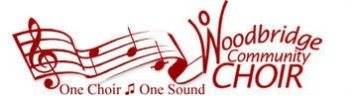

Here in concert order based on release date are links to recordings of song selections for the WCC Spring 2026 "What About Baby?" concert season (you might encounter ads):

Somebody Loves Me 1924
One For My Baby 1943
Put Your Head on My Shoulder TTBB only 1959
Be My Baby SSA only 1963
Can't Take My Eyes Off of You 1967
Sweet Baby James 1970
Who Loves You 1975
Baby, What a Big Surprise 1977
...Baby One More Time 1998
Everything 2007
Start a Fire 2014
Photograph 2015
Meant to Be 2017

